ITA0408 - Statistics with R Programming
Name : Pravin R
Reg. No : 192421292
Experiment 11: Read a CSV File and Display Contents
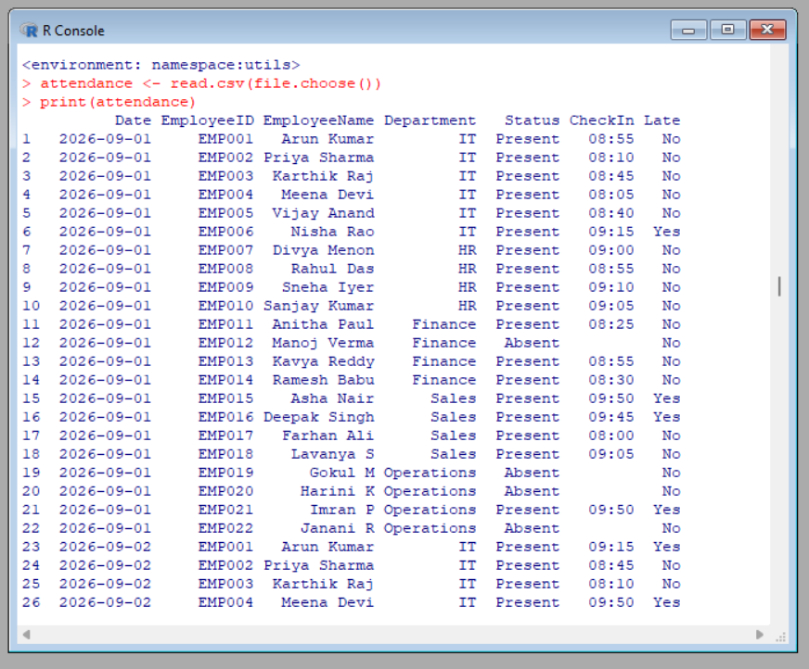
Experiment 12: Calculate Monthly Averages Using Air Quality Dataset
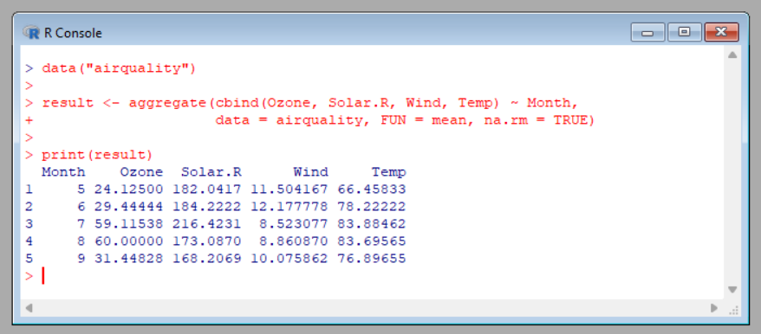
Experiment 13: Combine Multiple Arrays Row-Wise
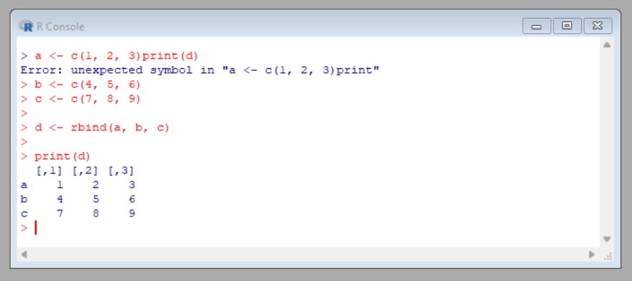
Experiment 14: Explore and Manipulate ChickWeight Dataset
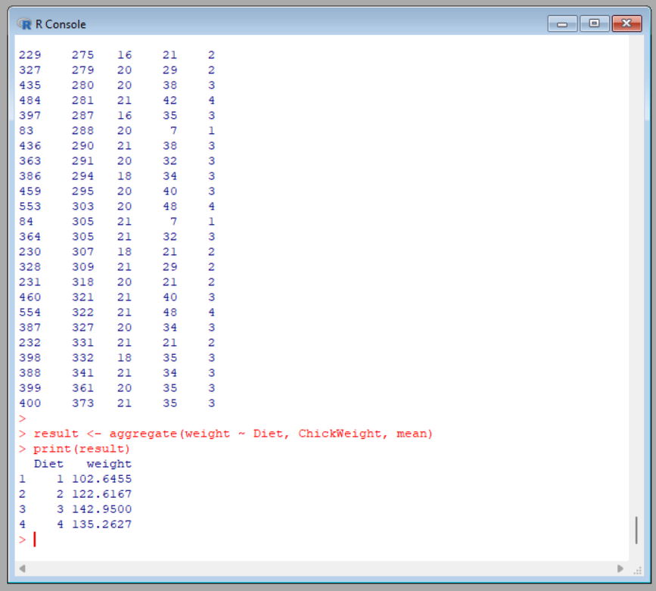

Experiment 15: Exploratory Data Analysis Using Iris Dataset
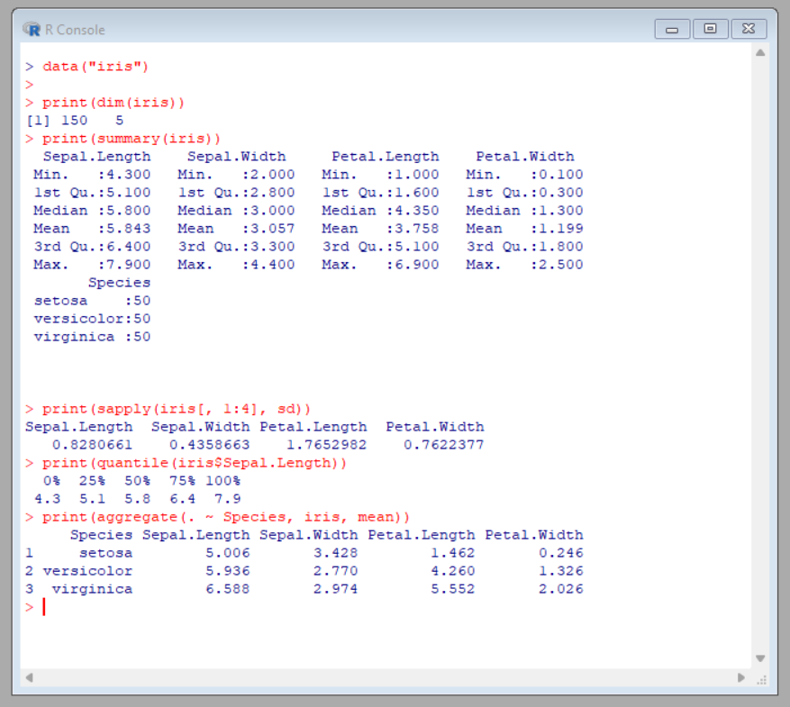
Experiment 16: Explore USArrests Dataset
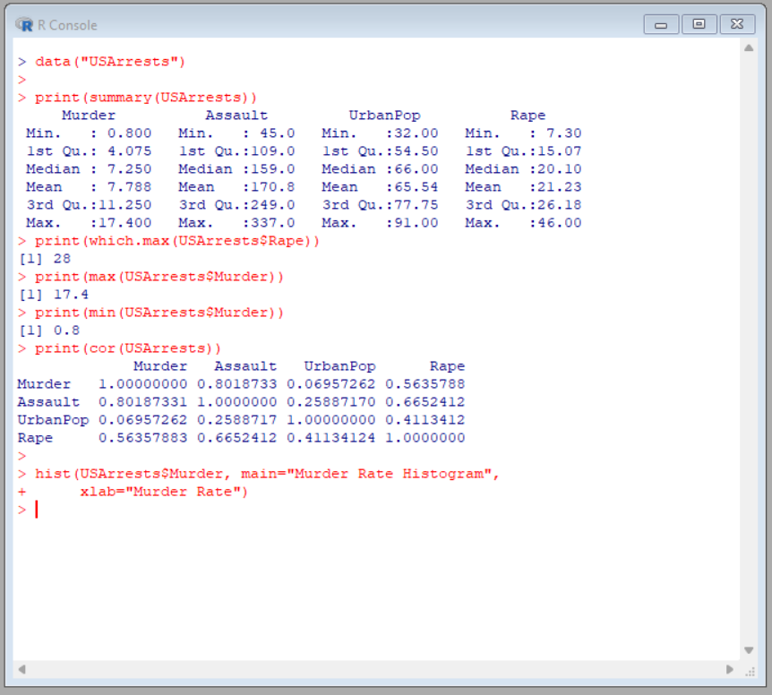
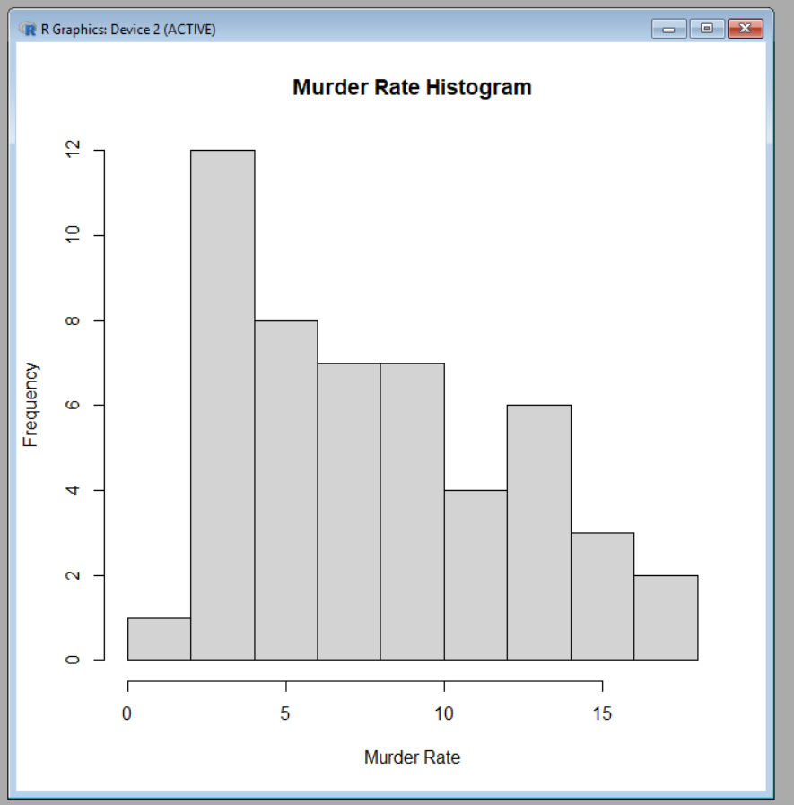
Experiment 17: Titanic Dataset Analysis Using Bar Charts
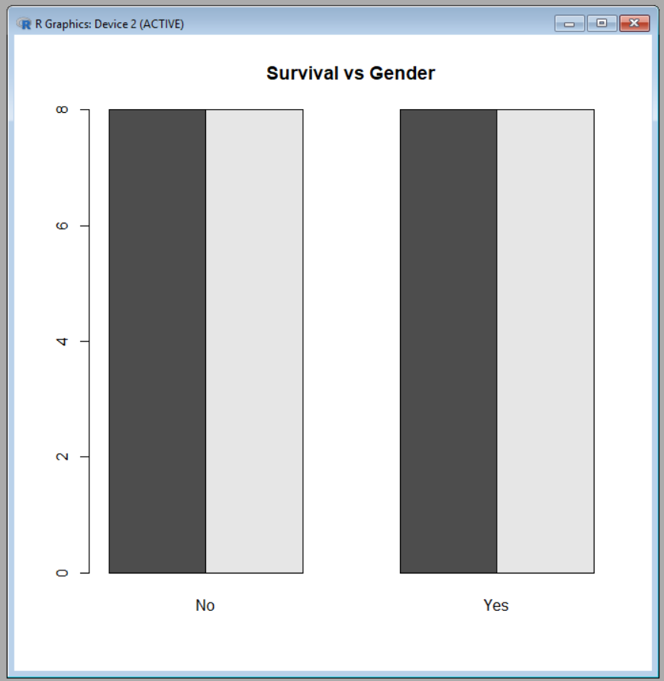
Experiment 18: Create Different Graphs in R
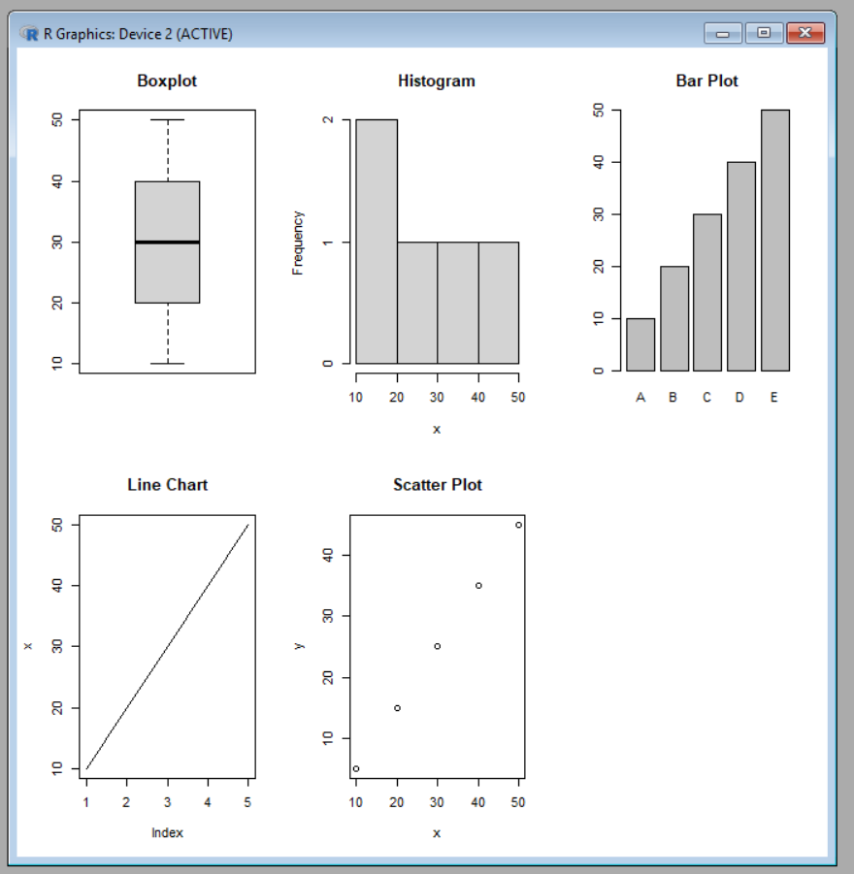
Experiment 19: Build a Linear Regression Model and Predict Sales
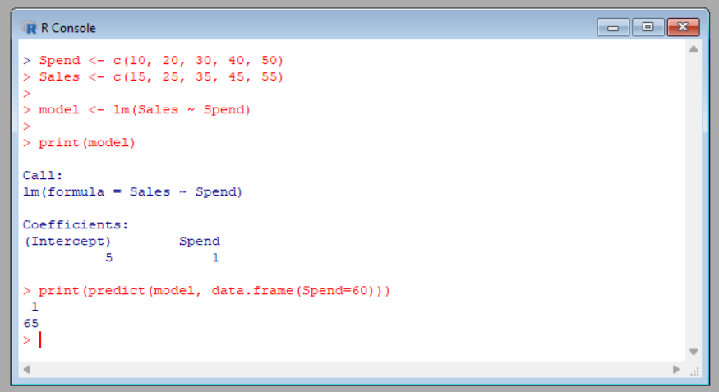

Experiment 20: Multiple Regression Using ChickWeight Dataset
